# Why we need Data Mining?

Volume of information is increasing everyday that we can handle from business transactions, scientific data, sensor data, Pictures, videos, etc. So, we need a system that will be capable of extracting essence of information available and that can automatically generate report, views or summary of data for better decision-making.

## Why Data Mining is used in Business?

Data mining is used in business to make better managerial decisions by:

* Automatic summarization of data
* Extracting essence of information stored.
* Discovering patterns in raw data.

# What is Data Mining?

Data Mining is defined as extracting information from huge sets of data. In other words, we can say that data mining is the procedure of mining knowledge from data. The information or knowledge extracted so can be used for any of the following applications −

* Market Analysis
* Fraud Detection
* Customer Retention
* Production Control
* Science Exploration

Knowledge discovery from Data (KDD) is essential for data mining. While others view data mining as an essential step in the process of knowledge discovery. Here is the list of steps involved in the knowledge discovery process −

* **Data Cleaning** − In this step, the noise and inconsistent data is removed.
* **Data Integration** − In this step, multiple data sources are combined.
* **Data Selection** − In this step, data relevant to the analysis task are retrieved from the database.
* **Data Transformation** − In this step, data is transformed or consolidated into forms appropriate for mining by performing summary or aggregation operations.
* **Data Mining** − In this step, intelligent methods are applied in order to extract data patterns.
* **Pattern Evaluation** − In this step, data patterns are evaluated.
* **Knowledge Presentation** − In this step, knowledge is represented.

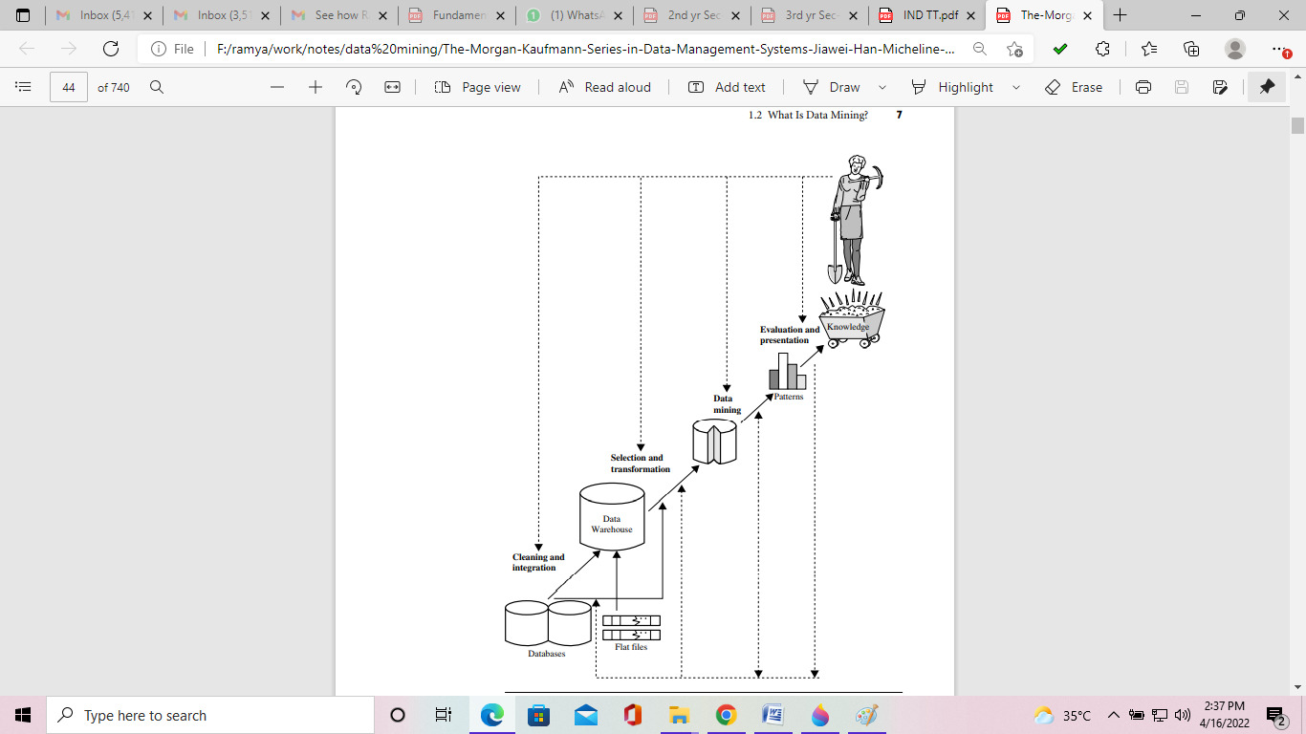

# What kinds of data can be mined?

1. Flat Files
2. Relational Databases
3. DataWarehouse
4. Transactional Databases
5. Multimedia Databases
6. Spatial Databases
7. Time Series Databases
8. World Wide Web(WWW)

##### Flat Files

* + Flat files are defined as data files in text form or binary form with a structure that can be easily extracted by data mining algorithms.
  + Data stored in flat files have no relationship or path among themselves, like if a relational database is stored on flat file, and then there will be no relations between the tables.
  + Flat files are represented by data dictionary. Eg: CSV file.
  + **Application**: Used in Data Warehousing to store data, Used in carrying data to and from server, etc.

##### Relational Databases

* + A Relational database is defined as the collection of data organized in tables with rows and columns.
  + Physical schema in Relational databases is a schema which defines the structure of tables.
  + Logical schema in Relational databases is a schema which defines the relationship among tables.
  + Standard API of relational database is SQL.
  + **Application**: Data Mining, ROLAP model, etc.

##### Data Warehouse

* + A datawarehouse is defined as the collection of data integrated from multiple sources that will query and decision making.
  + There are three types of datawarehouse: **Enterprise** datawarehouse, **Data Mart** and **Virtual** Warehouse.
  + Two approaches can be used to update data in DataWarehouse: **Query- driven** Approach and **Update-driven** Approach.
  + **Application**: Business decision making, Data mining, etc.

##### Transactional Databases

* + Transactional databases are a collection of data organized by time stamps, date, etc to represent transaction in databases.
  + This type of database has the capability to roll back or undo its operation when a transaction is not completed or committed.
  + Highly flexible system where users can modify information without changing any sensitive information.
  + Follows ACID property of DBMS.
  + **Application**: Banking, Distributed systems, Object databases, etc.

##### Multimedia Databases

* + Multimedia databases consists audio, video, images and text media.
  + They can be stored on Object-Oriented Databases.
  + They are used to store complex information in pre-specified formats.
  + **Application**: Digital libraries, video-on demand, news-on demand, musical database, etc.

##### Spatial Database

* + Store geographical information.
  + Stores data in the form of coordinates, topology, lines, polygons, etc.
  + **Application**: Maps, Global positioning, etc.

##### Time-series Databases

* + Time series databases contain stock exchange data and user logged activities.
  + Handles array of numbers indexed by time, date, etc.
  + It requires real-time analysis.
  + **Application**: eXtremeDB, Graphite, InfluxDB, etc.

##### WWW

* + WWW refers to World wide web is a collection of documents and resources like audio, video, text, etc which are identified by Uniform Resource Locators (URLs) through web browsers, linked by HTML pages, and accessible via the Internet network.
  + It is the most heterogeneous repository as it collects data from multiple resources.
  + It is dynamic in nature as Volume of data is continuously increasing and changing.
  + **Application**: Online shopping, Job search, Research, studying, etc.

# What kinds of Patterns can be mined?

On the basis of the kind of data to be mined, there are two categories of functions involved in Data Mining −

1. Descriptive
2. Classification and Prediction
3. **Descriptive Function**

The descriptive function deals with the general properties of data in the database.

Here is the list of descriptive functions −

* 1. Class/Concept Description
  2. Mining of Frequent Patterns
  3. Mining of Associations
  4. Mining of Correlations
  5. Mining of Clusters

#### Class/Concept Description

Class/Concept refers to the data to be associated with the classes or concepts. For example, in a company, the classes of items for sales include computer and printers, and concepts of customers include big spenders and budget spenders. Such descriptions of a class or a concept are called class/concept descriptions. These descriptions can be derived by the following two ways −

* + **Data Characterization** − This refers to summarizing data of class under study. This class under study is called as Target Class.
  + **Data Discrimination** − It refers to the mapping or classification of a class with some predefined group or class.

#### Mining of Frequent Patterns

Frequent patterns are those patterns that occur frequently in transactional data. Here is the list of kind of frequent patterns −

* + **Frequent Item Set** − It refers to a set of items that frequently appear together, for example, milk and bread.
  + **Frequent Subsequence** − A sequence of patterns that occur frequently such as purchasing a camera is followed by memory card.
  + **Frequent Sub Structure** − Substructure refers to different structural forms, such as graphs, trees, or lattices, which may be combined with item-sets or subsequences.

#### Mining of Association

Associations are used in retail sales to identify patterns that are frequently purchased together. This process refers to the process of uncovering the relationship among data and determining association rules.

For example, a retailer generates an association rule that shows that 70% of time milk is sold with bread and only 30% of times biscuits are sold with bread.

#### Mining of Correlations

It is a kind of additional analysis performed to uncover interesting statistical correlations between associated-attribute-value pairs or between two item sets to analyze that if they have positive, negative or no effect on each other.

#### Mining of Clusters

Cluster refers to a group of similar kind of objects. Cluster analysis refers to forming group of objects that are very similar to each other but are highly different from the objects in other clusters.

1. **Classification and Prediction**

Classification is the process of finding a model that describes the data classes or concepts. The purpose is to be able to use this model to predict the class of objects whose class label is unknown. This derived model is based on the analysis of sets of training data. The derived model can be presented in the following forms −

* 1. Classification (IF-THEN) Rules
  2. Prediction
  3. Decision Trees
  4. Mathematical Formulae
  5. Neural Networks
  6. Outlier Analysis
  7. Evolution Analysis

The list of functions involved in these processes is as follows −

1. **Classification** − It predicts the class of objects whose class label is unknown. Its objective is to find a derived model that describes and distinguishes data classes or concepts. The Derived Model is based on the analysis set of training data i.e. the data object whose class label is well known.
2. **Prediction** − It is used to predict missing or unavailable numerical data values rather than class labels. Regression Analysis is generally used for prediction. Prediction can also be used for identification of distribution trends based on available data.
3. **Decision Trees** − A decision tree is a structure that includes a root node, branches, and leaf nodes. Each internal node denotes a test on an attribute, each branch denotes the outcome of a test, and each leaf node holds a class label.
4. **Mathematical Formulae** – Data can be mined by using some mathematical formulas.
5. **Neural Networks** − Neural networks represent a brain metaphor for information processing. These models are biologically inspired rather than an exact replica of how the brain actually functions. Neural networks have been shown to be very promising systems in many forecasting applications and business classification applications due to their ability to “**learn**” from the data.
6. **Outlier Analysis** − Outliers may be defined as the data objects that do not comply with the general behavior or model of the data available.
7. **Evolution Analysis** − Evolution analysis refers to the description and model regularities or trends for objects whose behavior changes over time.

# Data Mining Task Primitives

* We can specify a data mining task in the form of a data mining query.
* This query is input to the system.
* A data mining query is defined in terms of data mining task primitives.

**Note** − These primitives allow us to communicate in an interactive manner with the data mining system. Here is the list of Data Mining Task Primitives −

* Set of task relevant data to be mined.
* Kind of knowledge to be mined.
* Background knowledge to be used in discovery process.
* Interestingness measures and thresholds for pattern evaluation.
* Representation for visualizing the discovered patterns.

# Which Technologies are used in data mining?

# 

#### Statistics:

* + It uses the mathematical analysis to express representations, model and summarize empirical data or real world observations.
  + Statistical analysis involves the collection of methods, applicable to large amount of data to conclude and report the trend.

#### Machine learning

* + **Arthur Samuel** defined machine learning as a field of study that gives computers the ability to learn without being programmed.
  + When the new data is entered in the computer, algorithms help the data to grow or change due to machine learning.
  + In machine learning, an algorithm is constructed to predict the data from the available database **(Predictive analysis).**
  + It is related to computational statistics.

#### The four types of machine learning are:

1. **Supervised learning**
   * It is based on the classification.
   * It is also called as **inductive learning**. In this method, the desired outputs are included in the training dataset.

#### Unsupervised learning

* + Unsupervised learning is based on clustering. Clusters are formed on the basis of similarity measures and desired outputs are not included in the training dataset.

#### Semi-supervised learning

* + Semi-supervised learning includes some desired outputs to the training dataset to generate the appropriate functions. This method generally avoids the large number of labeled examples (i.e. desired outputs).

#### Active learning

* + Active learning is a powerful approach in analyzing the data efficiently.
  + The algorithm is designed in such a way that, the desired output should be decided by the algorithm itself (the user plays important role in this type).

#### Information retrieval

* + Information deals with uncertain representations of the semantics of objects (text, images).

**For example:** Finding relevant information from a large document.

#### Database systems and data warehouse

* + Databases are used for the purpose of recording the data as well as data warehousing.
  + Online Transactional Processing (OLTP) uses databases for day to day transaction purpose.
  + Data warehouses are used to store historical data which helps to take strategically decision for business.
  + It is used for online analytical processing (OALP), which helps to analyze the data.

1. **PatternRecognition:**

Pattern recognition is the automated recognition of patterns and regularities in data. Pattern recognition is closely related to artificial intelligence and machine learning, together with applications such as data mining and knowledge discovery in databases (KDD), and is often used interchangeably with these terms.

#### Visualization:

It is the process of extracting and visualizing the data in a very clear and understandable way without any form of reading or writing by displaying the results in the form of pie charts, bar graphs, statistical representation and through graphical forms as well.

#### Algorithms:

To perform data mining techniques we have to design best algorithms.

#### High Performance Computing:

High Performance Computing most generally refers to the practice of aggregating computing power in a way that delivers much higher performance than one could get out of a typical desktop computer or workstation in order to solve large problems in science, engineering, or business.

# Are all patterns interesting?

* + Typically the answer is No – only small fraction of the patterns potentially generated would actuallybe of interest to a givenuser.
  + Whatmakespatternsinteresting?
    - The answer is if it is (1) easily understood byhumans, (2) valid on new or test data with somedegreeof certainty,(3) potentiallyuseful,(4) novel.
  + A Pattern is alsointerestingif it is validates a hypothesisthattheusersought to confirm.

# Data Mining Applications

Here is the list of areas where data mining is widely used −

* Financial Data Analysis
* Retail Industry
* Telecommunication Industry
* Biological Data Analysis
* Other Scientific Applications
* Intrusion Detection

#### Financial Data Analysis

The financial data in banking and financial industry is generally reliable and of high quality which facilitates systematic data analysis and data mining. Like,

* + Loan payment prediction and customer credit policy analysis.
  + Detection of money laundering and other financial crimes.

#### Retail Industry

Data Mining has its great application in Retail Industry because it collects large amount of data from on sales, customer purchasing history, goods transportation, consumption and services. It is natural that the quantity of data collected will continue to expand rapidly because of the increasing ease, availability and popularity of the web.

#### Telecommunication Industry

Today the telecommunication industry is one of the most emerging industries providing various services such as fax, pager, cellular phone, internet messenger, images, e- mail, web data transmission, etc. Due to the development of new computer and communication technologies, the telecommunication industry is rapidly expanding. This is the reason why data mining is become very important to help and understand the business.

#### Biological Data Analysis

In recent times, we have seen a tremendous growth in the field of biology such as genomics, proteomics, functional Genomics and biomedical research. Biological data mining is a very important part of Bioinformatics.

#### Other Scientific Applications

The applications discussed above tend to handle relatively small and homogeneous data sets for which the statistical techniques are appropriate. Huge amount of data have been collected from scientific domains such as geosciences, astronomy, etc.

A large amount of data sets is being generated because of the fast numerical simulations in various fields such as climate and ecosystem modeling, chemical engineering, fluid dynamics, etc.

#### Intrusion Detection

Intrusion refers to any kind of action that threatens integrity, confidentiality, or the availability of network resources. In this world of connectivity, security has become the major issue. With increased usage of internet and availability of the tools and tricks for intruding and attacking network prompted intrusion detection to become a critical component of network administration.

# Major Issues in data mining:

Data mining is a dynamic and fast-expanding field with great strengths. The major issues can divided into five groups:

1. Mining Methodology
2. User Interaction
3. Efficiency and scalability
4. Diverse Data Types Issues
5. Data mining society
6. **Mining Methodology:**

It refers to the following kinds of issues −

* + **Mining different kinds of knowledge in databases** − Different users may be interested in different kinds of knowledge. Therefore it is necessary for data mining to cover a broad range of knowledge discovery task.
  + **Mining knowledge in multidimensional space –** when searching for knowledge in large datasets, we can explore the data in multidimensional space.
  + **Handling noisy or incomplete data** − the data cleaning methods are required to handle the noise and incomplete objects while mining the data regularities. If the data cleaning methods are not there then the accuracy of the discovered patterns will be poor.
  + **Pattern evaluation** − the patterns discovered should be interesting because either they represent common knowledge or lack novelty.

#### User Interaction:

* + **Interactive mining of knowledge at multiple levels of abstraction** − The data mining process needs to be interactive because it allows users to focus the search for patterns, providing and refining data mining requests based on the returned results.
  + **Incorporation of background knowledge** − To guide discovery process and to express the discovered patterns, the background knowledge can be used. Background knowledge may be used to express the discovered patterns not only in concise terms but at multiple levels of abstraction.
  + **Data mining query languages and ad hoc data mining** − Data Mining Query language that allows the user to describe ad hoc mining tasks, should be integrated with a data warehouse query language and optimized for efficient and flexible data mining.
  + **Presentation and visualization of data mining results** − Once the patterns are discovered it needs to be expressed in high level languages, and visual representations. These representations should be easily understandable.

#### Efficiency and scalability

There can be performance-related issues such as follows −

* + **Efficiency and scalability of data mining algorithms** − In order to effectively extract the information from huge amount of data in databases, data mining algorithm must be efficient and scalable.
  + **Parallel, distributed, and incremental mining algorithms** − The factors such as huge size of databases, wide distribution of data, and complexity of data mining methods motivate the development of parallel and distributed data mining algorithms. These algorithms divide the data into partitions which is further processed in a parallel fashion. Then the results from the partitions is merged. The incremental algorithms, update databases without mining the data again from scratch.

1. **Diverse Data Types Issues**
   * **Handling of relational and complex types of data** − The database may contain complex data objects, multimedia data objects, spatial data, temporal data etc. It is not possible for one system to mine all these kind of data.
   * **Mining information from heterogeneous databases and global information systems** − The data is available at different data sources on LAN or WAN. These data source may be structured, semi structured or unstructured. Therefore mining the knowledge from them adds challenges to data mining.

#### Data Mining and Society

* + **Social impacts of data mining –** With data mining penetrating our everyday lives, it is important to study the impact of data mining on society.
  + **Privacy-preserving data mining –** data mining will help scientific discovery, business management, economy recovery, and security protection.
  + **Invisible data mining –** we cannot expect everyone in society to learn and master data mining techniques. More and more systems should have data mining functions built within so that people can perform data mining or use data mining results simply by mouse clicking, without any knowledge of data mining algorithms.

# Data Objects and Attribute Types:

#### Data Object:

An Object is real time entity.

#### Attribute:

It can be seen as a data field that represents characteristics or features of a data object. For a customer object attributes can be customer Id, address etc. The attribute types can represented as follows—

1. **Nominal Attributes – related to names:** The values of a Nominal attribute are name of things, some kind of symbols. Values of Nominal attributes represent some category or state and that’s why nominal attribute also referred as categorical attributes.

#### Example:

|  |  |
| --- | --- |
| **Attribute** | **Values** |
| Colors | Black, Green, Brown, red |

1. **Binary Attributes:** Binary data has only 2 values/states. For Example yes or no, affected or unaffected, true or false.
   1. Symmetric: Both values are equally important (Gender).
   2. 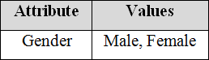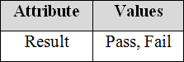Asymmetric: Both values are not equally important (Result).
2. **Ordinal Attributes:** The Ordinal Attributes contains values that have a meaningful sequence or ranking (order) between them, but the magnitude between values is not actually known, the order of values that shows what is important but don’t indicate how important it is.

|  |  |
| --- | --- |
| **Attribute** | **Values** |
| Grade | O, S, A, B, C, D, F |

1. **Numeric:** A numeric attribute is quantitative because, it is a measurable quantity, represented in integer or real values. Numerical attributes are of 2 types.
2. An **interval-scaled** attribute has values, whose differences are interpretable, but the numerical attributes do not have the correct reference point or we can call zero point. Data can be added and subtracted at interval scale but cannot be multiplied or divided. Consider an example of temperature in degrees Centigrade. If a day’s temperature of one day is twice than the other day we cannot say that one day is twice as hot as another day.
3. A **ratio-scaled** attribute is a numeric attribute with a fix zero-point. If a measurement is ratio-scaled, we can say of a value as being a multiple (or ratio) of another value. The values are ordered, and we can also compute the difference between values, and the mean, median, mode, Quantile-range and five number summaries can be given.
4. **Discrete:** Discrete data have finite values it can be numerical and can also be in categorical form. These attributes has finite or countably infinite set of values. **Example**

|  |  |
| --- | --- |
| **Attribute** | **Values** |
| Profession | Teacher, Business man,  Peon |
| ZIP Code | 521157, 521301 |

1. **Continuous:** Continuous data have infinite no of states. Continuous data is of float type. There can be many values between 2 and 3.

**Example**:

|  |  |
| --- | --- |
| **Attribute** | **Values** |
| Height | 5.4, 5.7, 6.2, etc., |
| Weight | 50, 65, 70, 73, etc., |

# Basic Statistical Descriptions of Data:

Basic Statistical descriptions of data can be used to identify properties of the data and highlight which data values should be treated as noise or outliers.

#### Measuring the central Tendency:

There are many ways to measure the central tendency.

* 1. ***Mean:*** Let us consider the values are be a set of N observed values or o
  2. bservations of X.

The Most common numeric measure of the “center” of a set of data is the *mean.*

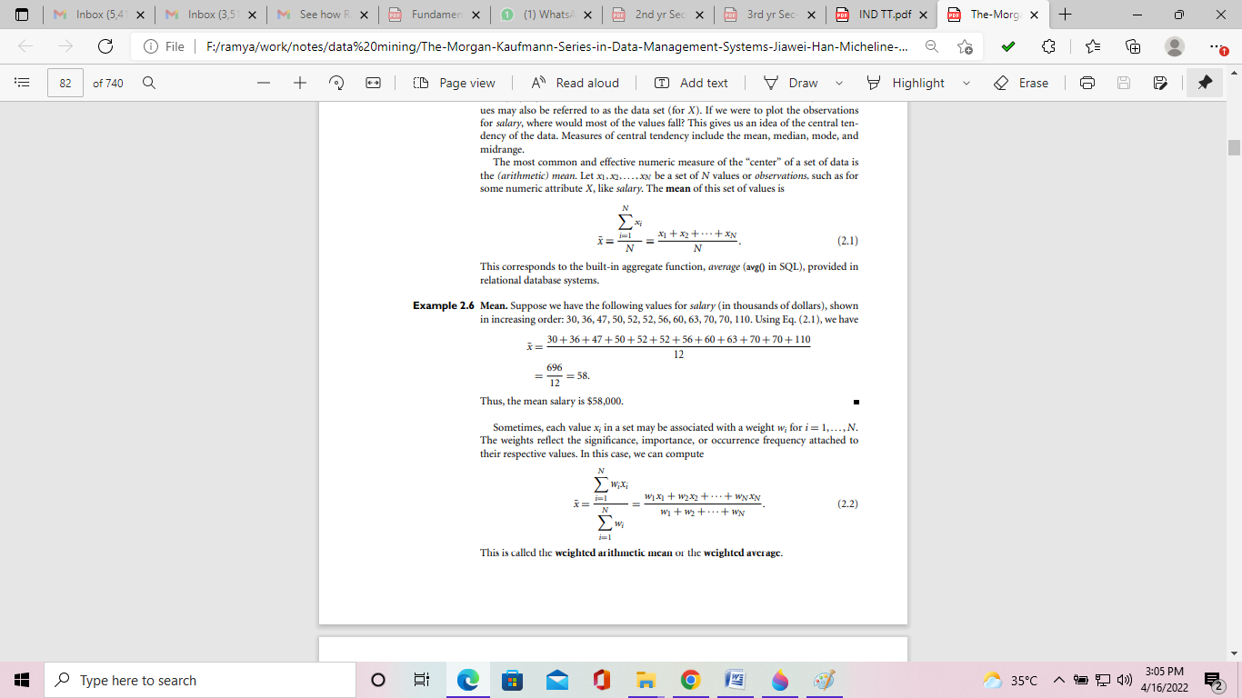

Sometimes, each value xi in a set may be associated with a weight wi for i = 1,...,N. The weights reflect the significance, importance, or occurrence frequency attached to their respective values. In this case, we can compute

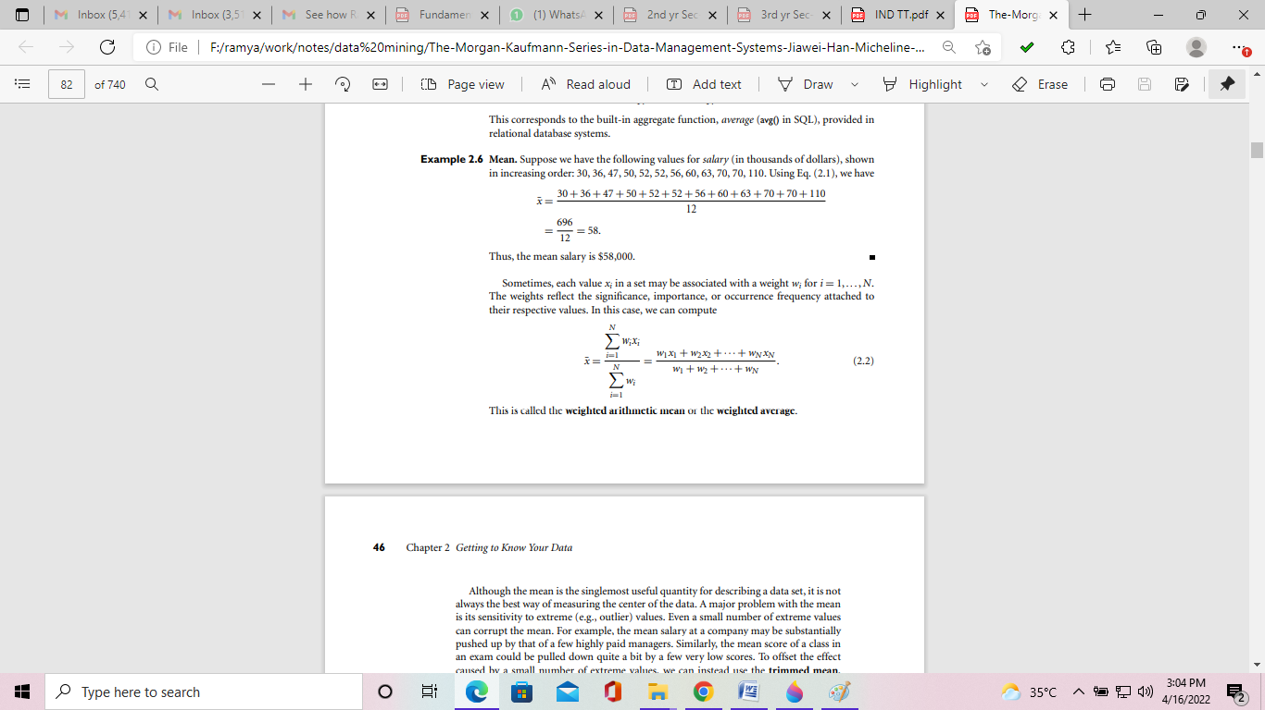

This is called **weighted arithmetic mean** or **weighted average**.

***Median:*** Median is middle value among all values.

### For N number of odd list median is [(n + 1) / 2] th value.

For N number of even list median is [(n/2)+1] th value.

**Mode**:

* + The *mode* is another measure of central tendency.
  + Datasets with one, two, or three modes are respectively called unimodal, bimodal, and trimodal.
  + A dataset with two or more modes is multimodal. If each data occurs only once,

then there is no mode.

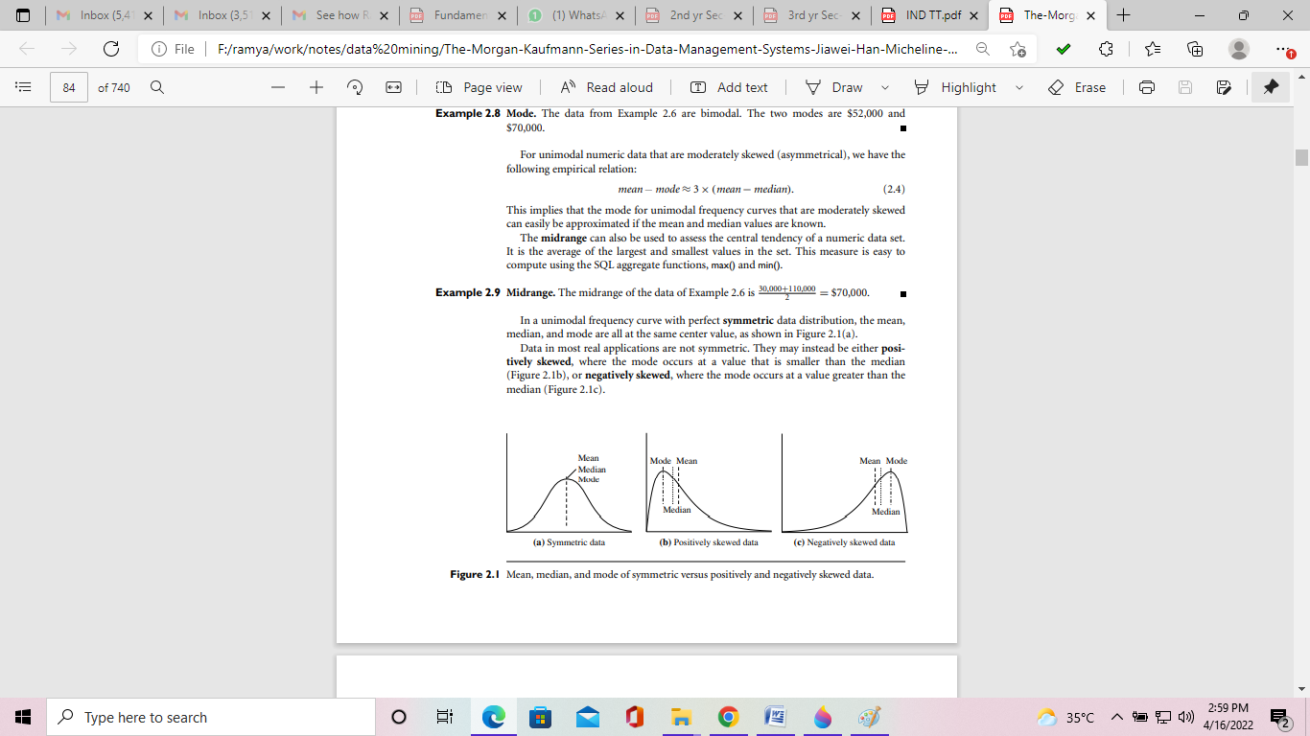

#### Measuring the Dispersion of data:

* The data can be measured as range, quantiles, quartiles, percentiles, and interquartile range.
* The kth percentile of a set of data in numerical order is the value xi having the property that k percent of the data entries lay at or below xi.
* The measures of data dispersion: Range, Five-number summary, Interquartile range (IQR), Variance and Standard deviation

#### Five Number Summary:

This contains five values Minimum, Q1 (25% value), Median, Q3 (75% value), and Maximum. These Five numbers are represented as Boxplot in graphical format.

* Boxplot is Data is represented with a box.
* The ends of the box are at the first and third quartiles, i.e., the height of the box is IRQ.
* The median is marked by a line within the box.
* Whiskers: two lines outside the box extend to Minimum and Maximum.
* To show outliers, the whiskers are extended to the extreme low and high observations only if these values are less than 1.5 * IQR beyond the quartiles.

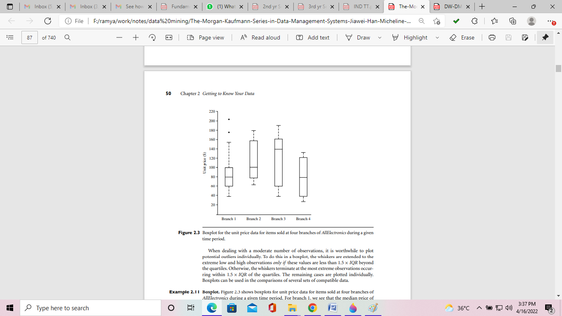

#### Variance and Standard Deviation:

Let us consider the values are be a set of N observed values or observations of X. The variance formula is

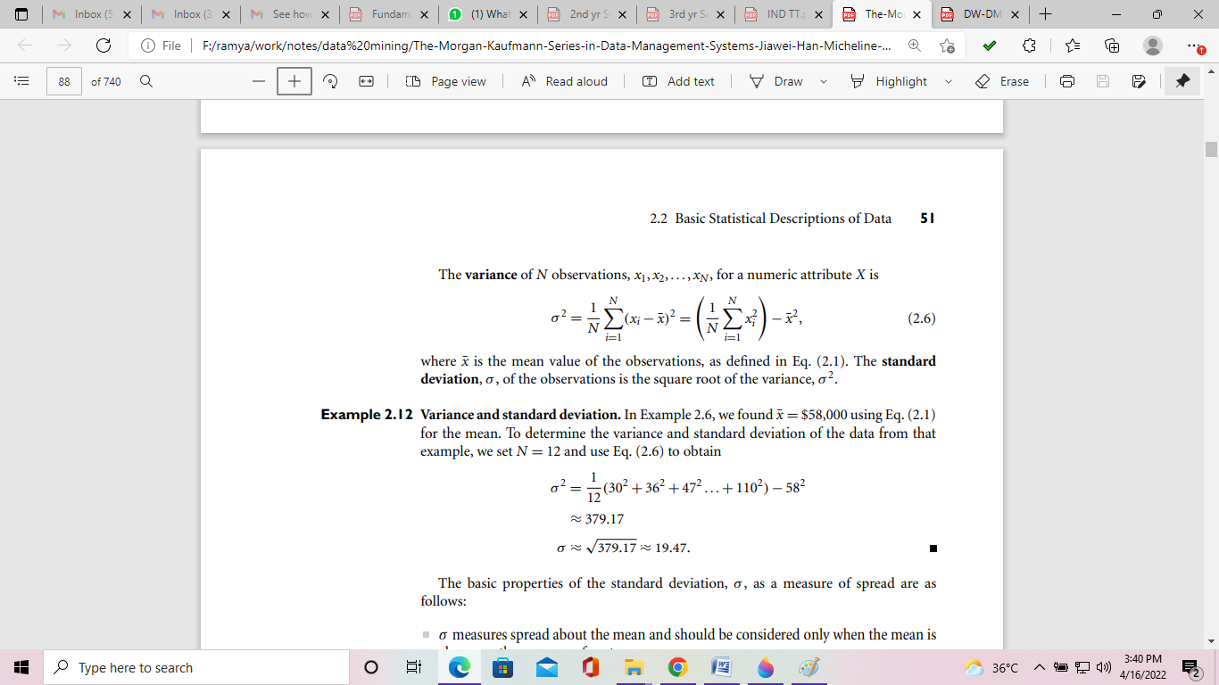

* + Standard Deviation is the square root of variance σ2.
  + σ measures spread about the mean and should be used only when the mean is chosen as the measure of center.
  + σ =0 only when there is no spread, that is, when all observations have the same value.

1. **Graphical Displays of Basic Statistical data:**

There are many types of graphs for the display of data summaries and distributions, such as:

* Bar charts
* Pie charts
* Line graphs
* Boxplot
* Histograms
* Quantile plots, Quantile - Quantile plots
* Scatter plots

The data values can represent as Bar charts, pie charts, Line graphs, etc.

#### Quantile plots:

* A quantile plot is a simple and effective way to have a first look at a univariate data distribution.
* Plots quantile information
  + For a data xi data sorted in increasing order, fi indicates that approximately 100 fi% of the data are below or equal to the value xi
* Note that
  + the 0.25 quantile corresponds to quartile Q1,
  + the 0.50 quantile is the median, and
  + the 0.75 quantile is Q3.

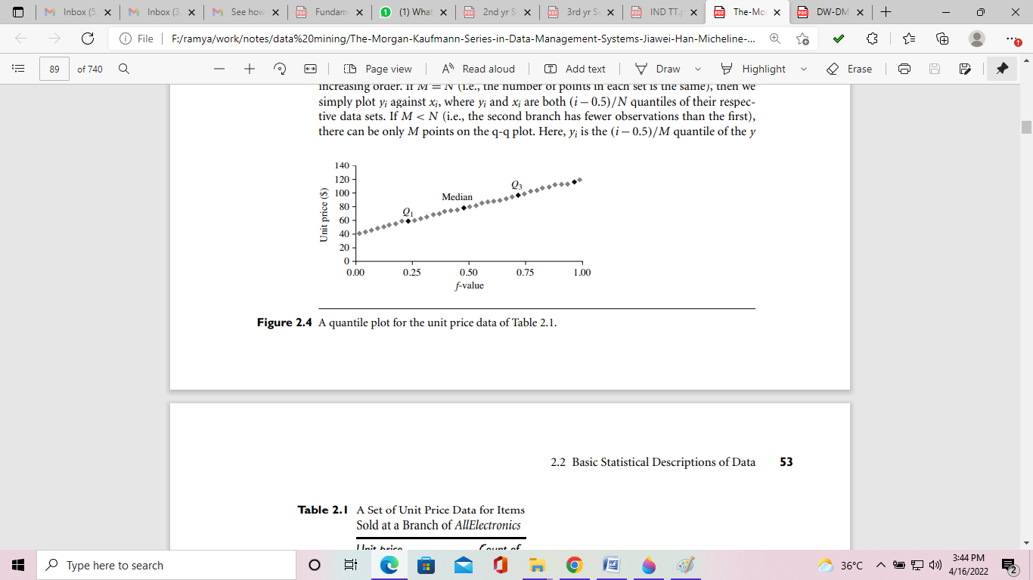

#### Quantile - Quantile plots:

In statistics, a Q-Q plot is a portability plot, which is a graphical method for comparing two portability distributions by plotting their quantiles against each other.

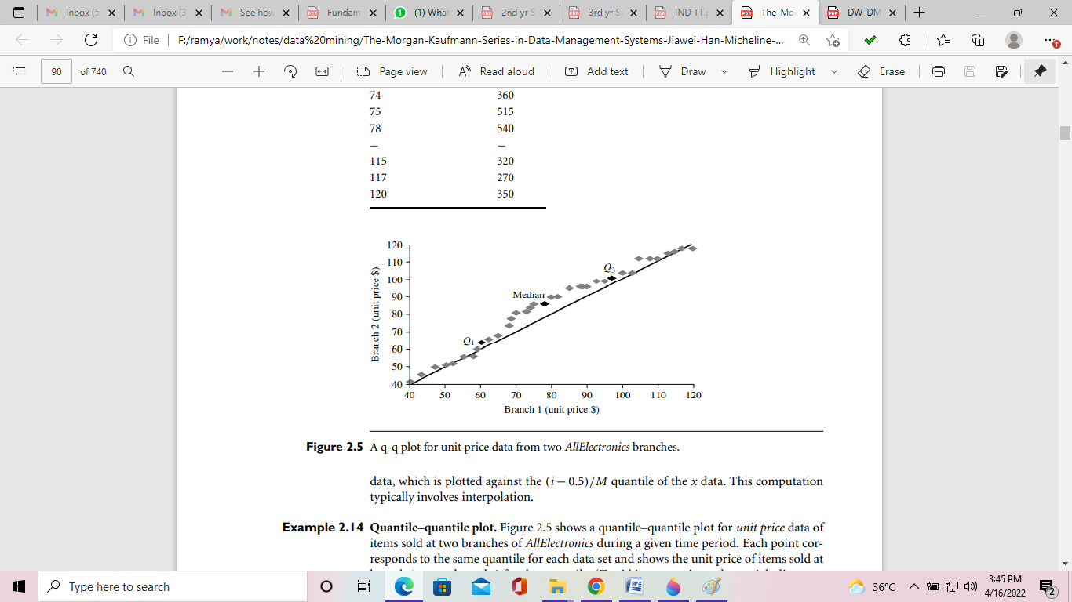

#### Histograms *or* frequency histograms:

* A univariate graphical method
* Consists of a set of rectangles that reflect the counts or frequencies of the classes present in the given data
* If the attribute is categorical, then one rectangle is drawn for each known value of A, and the resulting graph is more commonly referred to as a bar chart.
* If the attribute is numeric, the term histogram is preferred.

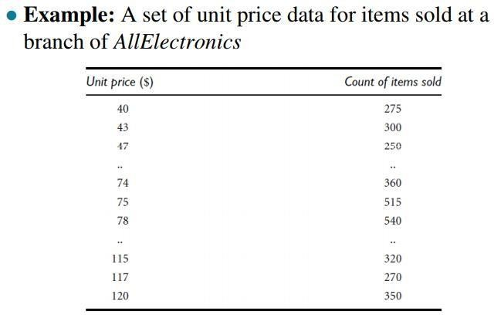 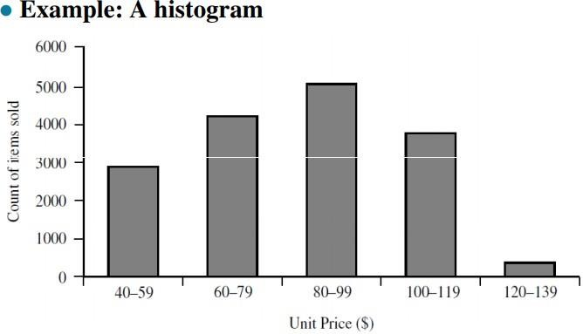

#### Scatter Plot:

* Scatter plot
  + Is one of the most effective graphical methods for determining if there appears to be a relationship, clusters of points, or outliers between two numerical attributes.
* Each pair of values is treated as a pair of coordinates and plotted as points in the plane

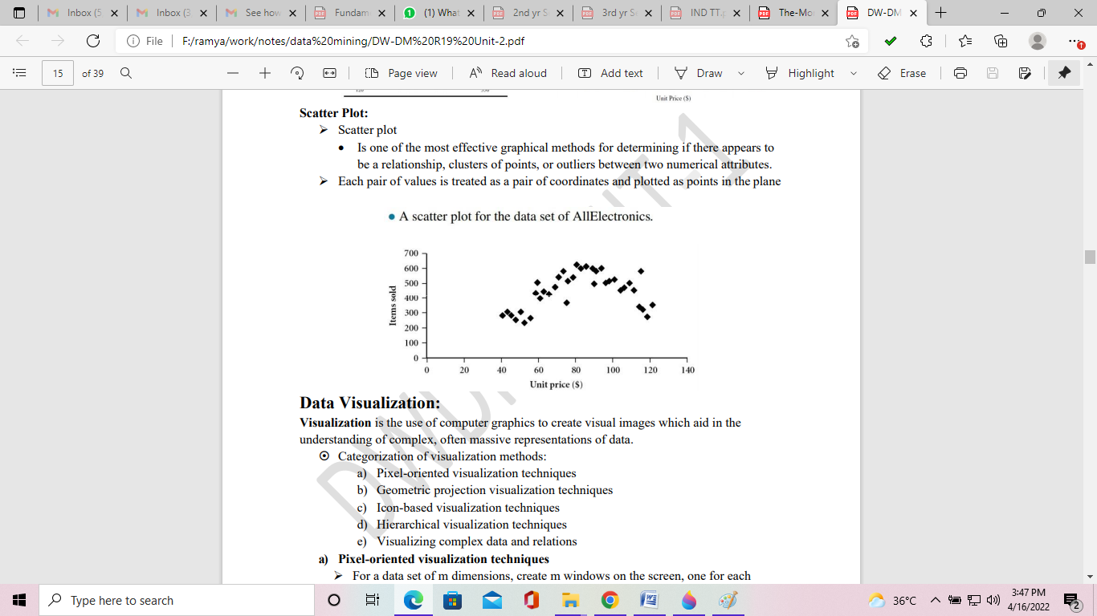

# Similarity and Dissimilarity

Distance or similarity measures are essential to solve many pattern recognition problems such as classification and clustering. Various distance/similarity measures are available in literature to compare two data distributions. As the names suggest, a similarity measures how close two distributions are. For multivariate data complex summary methods are developed to answer this question.

#### Similarity Measure

* Numerical measure of how alike two data objects are.
* Often falls between 0 (no similarity) and 1 (complete similarity).

#### Dissimilarity Measure

* Numerical measure of how different two data objects are.
* Range from 0 (objects are alike) to ∞ (objects are different). **Proximity** refers to a similarity or dissimilarity. ***Similarity/Dissimilarity for Simple Attributes***

Here, *p* and *q* are the attribute values for two data objects.

#### Common Properties of Dissimilarity Measures

**Distance**, such as the Euclidean distance, is a dissimilarity measure and has some well known properties:

1. *d*(*p*, *q*) ≥ 0 for all *p* and *q*, and *d*(*p*, *q*) = 0 if and only if *p* = *q*,
2. *d*(*p*, *q*) = *d(q,p)* for all *p* and *q*,
3. *d*(*p*, *r*) ≤ *d*(*p*, *q*) + *d*(*q*, *r*) for all *p*, *q*, and r, where *d*(*p*, *q*) is the distance (dissimilarity) between points (data objects), *p* and *q*.

A distance that satisfies these properties are called a **metric**. Following is a list of several common distance measures to compare multivariate data. We will assume that the attributes are all continuous.

##### Euclidean Distance

Assume that we have measurements xik, *i* = 1, … , *N*, on variables *k* = 1, … , *p* (also called attributes).

The Euclidean distance between the *i*th and *j*th objects is



for every pair (i, j) of observations. The weighted Euclidean distance is 

If scales of the attributes differ substantially, standardization is necessary.

##### Minkowski Distance

The Minkowski distance is a generalization of the Euclidean distance.

With the measurement, *xik* , *i* = 1, … , *N*, k = 1, … , *p*, the Minkowski distance is

where λ ≥ 1. It is also called the Lλ metric.

λ = 1 : L1 metric, Manhattan or City-block distance. λ = 2 : L2 metric, Euclidean distance.

λ → ∞ : L∞ metric, Supremum distance.

Note that λ and p are two different parameters. Dimension of the data matrix remains finite.

##### Mahalanobis Distance

Let **X** be a N × p matrix. Then the ith row of **X** is

The Mahalanobis distance is



where ∑ is the p×p sample covariance matrix.

#### Common Properties of Similarity Measures

Similarities have some well known properties:

* 1. *s*(*p*, *q*) = 1 (or maximum similarity) only if *p* = *q*,
  2. *s*(*p*, *q*) = *s*(*q*, *p*) for all *p* and *q*, where *s*(*p*, *q*) is the similarity between data objects, *p* and *q*.

##### Similarity between Two Binary Variables

The above similarity or distance measures are appropriate for continuous variables. However, for binary variables a different approach is necessary.

|  |  |  |
| --- | --- | --- |
|  | Q=1 | Q=0 |
| P=1 | N1,1 | N1,0 |
| P=0 | N0,1 | N0,0 |

Simple Matching and Jaccard Coefficients

Simple matching coefficient = (*n*1,1+ *n*0,0) / (*n*1,1 + *n*1,0 + *n*0,1 + *n*0,0). Jaccard coefficient = *n*1,1 / (*n*1,1 + *n*1,0 + *n*0,1).

# DATA PREPROCESSING

1. **Preprocessing**

Real-world databases are highly susceptible to noisy, missing, and inconsistent data due to their typically huge size (often several gigabytes or more) and their likely origin from multiple, heterogeneous sources. Low-quality data will lead to low-quality mining results, so we prefer a preprocessing concepts.

Data Preprocessing Techniques

* + **Data cleaning** can be applied to remove noise and correct inconsistencies in the data.
  + **Data integration** merges data from multiple sources into coherent data store, such as a data warehouse.
  + **Data reduction** can reduce the data size by aggregating, eliminating redundant features, or clustering, for instance. These techniques are not mutually exclusive; they may work together.
  + **Data transformations**, such as normalization, may be applied.

## Need for preprocessing

* Incomplete, noisy and inconsistent data are common place properties of large real world databases and data warehouses.
* Incomplete data can occur for a number of reasons:
  + Attributes of interest may not always be available
  + Relevant data may not be recorded due to misunderstanding, or because of equipment malfunctions.
  + Data that were inconsistent with other recorded data may have been deleted.
  + Missing data, particularly for tuples with missing values for some attributes, may need to be inferred.
  + The data collection instruments used may be faulty.
  + There may have been human or computer errors occurring at data entry.
  + Errors in data transmission can also occur.
  + There may be technology limitations, such as limited buffer size for coordinating synchronized data transfer and consumption.
  + Data cleaning routines work to ―clean‖ the data by filling in missing values, smoothing noisy data, identifying or removing outliers, and resolving inconsistencies.
  + Data integration is the process of integrating multiple databases cubes or files. Yet some attributes representing a given may have different names in different databases, causing inconsistencies and redundancies.
  + Data transformation is a kind of operations, such as normalization and aggregation, are additional data preprocessing procedures that would contribute toward the success of the mining process.
  + Data reduction obtains a reduced representation of data set that is much smaller in volume, yet produces the same(or almost the same) analytical results.

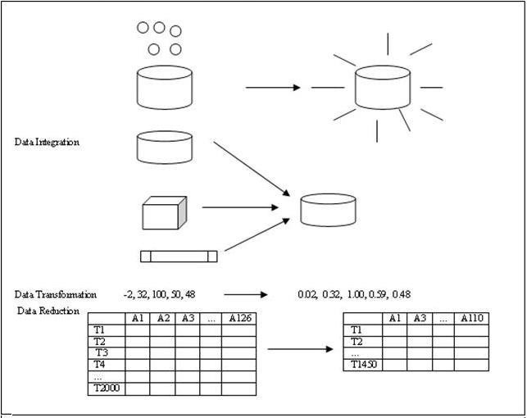

# DATA CLEANING

Real-world data tend to be incomplete, noisy, and inconsistent. Data cleaning (or data cleansing) routines attempt to fill in missing values, smooth out noise while identifying outliers and correct inconsistencies in the data.

##### Missing Values

Many tuples have no recorded value for several attributes, such as customer income.so we can fill the missing values for this attributes.

The following methods are useful for performing missing values over several attributes:

1. **Ignore the tuple**: This is usually done when the class label missing (assuming the mining task involves classification). This method is not very effective, unless the tuple contains several attributes with missing values. It is especially poor when the percentage of the missing values per attribute varies considerably.
2. **Fill in the missing values manually**: This approach is time –consuming and may not be feasible given a large data set with many missing values.
3. **Use a global constant to fill in the missing value**: Replace all missing attribute value by the same constant, such as a label like ―unknown‖ or -∞.
4. **Use the attribute mean to fill in the missing value**: For example, suppose that the average income of customers is $56,000. Use this value to replace the missing value for income.
5. **Use the most probable value to fill in the missing value**: This may be determined with regression, inference-based tools using a Bayesian formalism or decision tree induction. For example, using the other customer attributes in the sets decision tree is constructed to predict the missing value for income.

##### Noisy Data

Noise is a random error or variance in a measured variable. Noise is removed using data smoothing techniques.

**Binning:** Binning methods smooth a sorted data value by consulting its ―neighborhood,‖ that is the value around it. The sorted values are distributed into a number of ―buckets‖ or ―bins―.

Because binning methods consult the neighborhood of values, they perform local smoothing. Sorted data for price (in dollars): 3,7,14,19,23,24,31,33,38.

Example 1: Partition into (equal-frequency) bins:

Bin 1: 3,7,14

Bin 2: 19,23,24

Bin 3: 31,33,38

In the above method the data for price are first sorted and then partitioned into equal- frequency bins of size 3.

**Smoothing by bin means:**

Bin 1: 8,8,8

Bin 2: 22,22,22

Bin 3: 34,34,34

In smoothing by bin means method, each value in a bin is replaced by the mean value of the bin. For example, the mean of the values 3,7&14 in bin 1 is 8[(3+7+14)/3].

#### Smoothing by bin boundaries:

Bin 1: 3,3,14

Bin 2: 19, 24, 24

Bin 3: 31, 31, 38

In smoothing by bin boundaries, the maximum & minimum values in give bin or identify as the bin boundaries. Each bin value is then replaced by the closest boundary value.

In general, the large the width, the greater the effect of the smoothing. Alternatively, bins may be equal-width, where the interval range of values in each bin is constant Example 2: Remove the noise in the following data using smoothing techniques:

8, 4,9,21,25,24,29,26,28,15

Sorted data for price (in dollars):4,8,9,15,21,21,24,25,26,28,29,34

#### Partition into equal-frequency (equi-depth) bins:

Bin 1: 4, 8,9,15

Bin 2: 21,21,24,25

Bin 3: 26,28,29,34

#### Smoothing by bin means:

Bin 1: 9,9,9,9

Bin 2: 23,23,23,23

Bin 3: 29,29,29,29

#### Smoothing by bin boundaries:

Bin 1: 4, 4,4,15

Bin 2: 21,21,25,25

Bin3: 26,26,26,34

**Regression:** Data can be smoothed by fitting the data to function, such as with regression. Linear regression involves finding the ―best‖ line to fit two attributes (or variables), so that one attribute can be used to predict the other. Multiple linear regressions is an extension of linear regression, where more than two attributes are involved and the data are fit to a multidimensional surface.

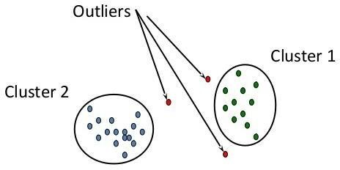**Clustering:** Outliers may be detected by clustering, where similar values are organized into groups, or ―clusters.‖ Intuitively, values that fall outside of the set of clusters may be considered outliers.

##### Inconsistent Data

Inconsistencies exist in the data stored in the transaction. Inconsistencies occur due to occur during data entry, functional dependencies between attributes and missing values. The inconsistencies can be detected and corrected either by manually or by knowledge engineering tools.

##### Data cleaning as a process

1. Discrepancy detection
2. Data transformations

##### Discrepancy detection

The first step in data cleaning is discrepancy detection. It considers the knowledge ofmeta data and examines the following rules for detecting the discrepancy.

*Unique rules*- each value of the given attribute must be different from all other values for that attribute.

*Consecutive rules* – Implies no missing values between the lowest and highest values for the attribute and that all values must also be unique.

*Null rules* - specifies the use of blanks, question marks, special characters, or other strings that may indicates the null condition

##### Discrepancy detection Tools:

* + Data scrubbing tools - use simple domain knowledge (e.g., knowledge of postal addresses, and spell-checking) to detect errors and make corrections in the data
  + Data auditing tools – analyzes the data to discover rules and relationship, and detecting data that violate such conditions.

##### Data transformations

This is the second step in data cleaning as a process. After detecting discrepancies, we need to define and apply (a series of) transformations to correct them.

##### Data Transformations Tools:

* + Data migration tools – allows simple transformation to be specified, such to replaced the string ―gender‖ by ―sex‖.
  + ETL (Extraction/Transformation/Loading) tools – allows users to specific transforms through a graphical user interface(GUI)

# Data Integration

Data mining often requires data integration - the merging of data from stores into a coherent data store, as in data warehousing. These sources may include multiple data bases, data cubes, or flat files.

##### Issues in Data Integration

* 1. Schema integration & object matching.
  2. Redundancy.
  3. Detection & Resolution of data value conflict

1. ***Schema Integration & Object Matching***

Schema integration & object matching can be tricky because same entity can be represented in different forms in different tables. This is referred to as the entity identification problem. Metadata can be used to help avoid errors in schema integration. The meta data may also be used to help transform the data.

### Redundancy:

Redundancy is another important issue an attribute (such as *annual revenue*, for instance) may be redundant if it can be ―derived‖ from another attribute are set of attributes. Inconsistencies in attribute of dimension naming can also cause redundancies in the resulting data set. Some redundancies can be detected by correlation analysis and covariance analysis.

For Nominal data, we use the 2 (Chi-Square) test.

For Numeric attributes we can use the correlation coefficient and covariance.

#### 2Correlation analysis for numerical data:

For nominal data, a correlation relationship between two attributes, A and B, can be discovered by a 2 (Chi-Square) test. Suppose A has c distinct values, namely a1, a2, a3,

……., ac. B has r distinct values, namely b1, b2, b3, …., br. The data tuples are described by table.

The 2 value is computed as

**2**

𝒄

𝒊=𝟏

**=**

𝒓

𝒋=𝟏

𝟐

𝒐𝒊𝒋−𝒆𝒊𝒋

𝒆𝒊𝒋

Where oij is the observed frequency of the joint event (Ai,Bj) and eij is the expected frequency of (Ai,Bj), which can computed as

For Example,

**eij**

**=**𝒄𝒐𝒖𝒏𝒕 𝑨=𝒂𝒊 𝑿𝒄𝒐𝒖𝒏𝒕(𝑩=𝒃𝒋)

𝒏

|  |  |  |  |
| --- | --- | --- | --- |
|  | **Male** | **Female** | **Total** |
| **Fiction** | 250 | 200 | 450 |
| **Non_Fiction** | 50 | 1000 | 1050 |
| **Total** | 300 | 1200 | 1500 |

𝑐𝑜𝑢𝑛𝑡 𝑚𝑎𝑙𝑒 𝑋𝑐𝑜𝑢𝑛𝑡 (𝑓𝑖𝑐𝑡𝑖𝑜𝑛 ) 300 𝑋450

**e** = = = 90

**11** 𝑛 1500

**e** = 𝑐𝑜𝑢𝑛𝑡 𝑚𝑎𝑙𝑒 𝑋𝑐𝑜𝑢𝑛𝑡 (𝑛𝑜𝑛 _𝑓𝑖𝑐𝑡𝑖𝑜𝑛 ) = 300 𝑋1050 = 210

**12**

𝑛 1500

**e** = 𝑐𝑜𝑢𝑛𝑡 𝑓𝑒𝑚𝑎𝑙𝑒 𝑋𝑐𝑜𝑢𝑛𝑡 (𝑓𝑖𝑐𝑡𝑖𝑜𝑛 ) = 1200 𝑋450 = 360

**21**

𝑛 1500

**e** = 𝑐𝑜𝑢𝑛𝑡 𝑓𝑒𝑚𝑎𝑙𝑒 𝑋𝑐𝑜𝑢𝑛𝑡 (𝑛𝑜𝑛 _𝑓𝑖𝑐𝑡𝑖𝑜𝑛 ) = 1200 𝑋1050 = 840

**22**

𝑛 1500

|  |  |  |  |
| --- | --- | --- | --- |
|  | **Male** | **Female** | **Total** |
| **Fiction** | 250 (90) | 200 (360) | 450 |
| **Non_Fiction** | 50 (210) | 1000 (840) | 1050 |
| **Total** | 300 | 1200 | 1500 |

For 2 computation, we get

2 =(250−90)2 + (50−210)2 + 200 −360 2 + (1000 −840)2

90 210 360 840

= 284.44 + 121.90 + 71.11 + 30.48 = 507.93

For this 2 X 2 table, the degrees of freedom are (2-1(2-1)=1. For 1 degree of freedom, the x2 value needed to reject the hypothesis at the 0.001 significance level is 10.828(from statistics table). Since our computed value is greater than this, we can conclude that two attributes are strongly correlated for the given group of people.

#### Correlation Coefficient for Numeric data:

For Numeric attributes, we can evaluate the correlation between two attributes, A and B, by computing the correlation coefficient. This is

𝒏 𝒂𝒊−𝑨 𝒃𝒊−𝑩 𝒏 𝒂𝒊𝒃𝒊 −𝒏𝑨𝑩

**rA,B =** 𝒊=𝟏

𝒏𝝈𝑨

𝝈𝑩

**=** 𝒊=𝟏 𝒏𝝈

𝑨𝝈𝑩

For Covariance between A and B defined as

𝒏 𝒂𝒊−𝑨 𝒃𝒊−𝑩

**Cov(A,B) =** 𝒊=𝟏

𝒏

### Detection and Resolution of Data Value Conflicts.

A third important issue in data integration is the *detection and resolution of data valueconflicts*. For example, for the same real–world entity, attribute value from differentsources may differ. This may be due to difference in representation, scaling, or encoding.

For instance, a weight attribute may be stored in metric units in one system and British imperial units in another. For a hotel chain, the *price* of rooms in different cities may involve not only different currencies but also different services (such as free breakfast) and taxes. An attribute in one system may be recorded at a lower level of abstraction than the

―same‖ attribute in another.

Careful integration of the data from multiple sources can help to reduce and avoid redundancies and inconsistencies in the resulting data set. This can help to improve the accuracy and speed of the subsequent of mining process.

# Data Reduction:

Obtain a reduced representation of the data set that is much smaller in volume but yet produces the same (or almost the same) analytical results.

Why data reduction? — A database/data warehouse may store terabytes of data.

Complex data analysis may take a very long time to run on the complete data set.

Data reduction strategies 4.1.Data cube aggregation 4.2.Attribute Subset Selection

4.3.Numerosity reduction — e.g., fit data into models 4.4.Dimensionality reduction - Data Compression

## Data cube aggregation:

For example, the data consists of AllElectronics sales per quarter for the years 2014 to 2017.You are, however, interested in the annual sales, rather than the total per quarter. Thus, the data can be ***aggregated***so that the resulting data summarize the total sales per year instead of per quarter.

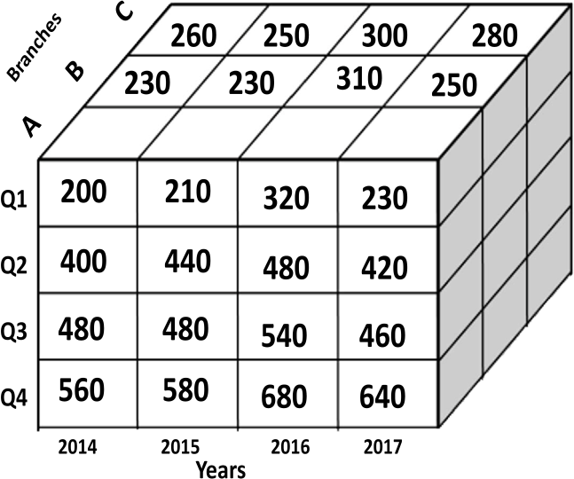

|  |  |  |  |  |  |  |  |
| --- | --- | --- | --- | --- | --- | --- | --- |
| **Year/Quarter** | **2014** | **2015** | **2016** | **2017** |  | **Year** | **Sales** |
| **Quarter 1** | 200 | 210 | 320 | 230 | 2014 | 1640 |
| **Quarter 2** | 400 | 440 | 480 | 420 | 2015 | 1710 |
| **Quarter 3** | 480 | 480 | 540 | 460 | 2016 | 2020 |
| **Quarter 4** | 560 | 580 | 680 | 640 | 2017 | 1750 |

## Attribute Subset Selection

Attribute subset selection reduces the data set size by removing irrelevant or redundant attributes (or dimensions). The goal of attribute subset selection is to find a minimum set of attributes. It reduces the number of attributes appearing in the discovered patterns, helping to make the patterns easier to understand.

For *n* attributes, there are 2*n* possible subsets. An exhaustive search for the optimal subset of attributes can be prohibitively expensive, especially as *n* and the number of data classes increase. Therefore, heuristic methods that explore a reduced search space are commonly used for attribute subset selection. These methods are typically greedy in that, while searching to attribute space, they always make what looks to be the best choice at that time. Their strategy to make a locally optimal choice in the hope that this will lead to a

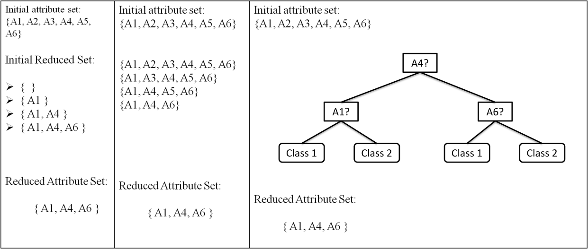globally optimal solution. Many other attributes evaluation measure can be used, such as the information gain measure used in building decision trees for classification.

Techniques for heuristic methods of attribute sub set selection

* Stepwise forward selection
* Stepwise backward elimination
* Combination of forward selection and backward elimination
* Decision tree induction

1. ***Stepwise forward selection***: The procedure starts with an empty set of attributes as the reduced set. The best of original attributes is determined and added to the reduced set. At each subsequent iteration or step, the best of the remaining original attributes is added to the set.
2. ***Stepwise backward elimination***: The procedure starts with full set of attributes. At each step, it removes the worst attribute remaining in the set.
3. ***Combination of forward selection and backward elimination****:* The stepwise forward selection and backward elimination methods can be combined so that, at each step, the procedure selects the best attribute and removes the worst from among the remaining attributes.
4. ***Decision tree induction****:* Decision tree induction constructs a flowchart like structure where each internal node denotes a test on an attribute, each branch corresponds to an outcome of the test, and each leaf node denotes a class prediction. At each node, the algorithm choices the ―best‖ attribute to partition the data into individual classes. A tree is constructed from the given data. All attributes that do not appear in the tree are assumed to be irrelevant. The set of attributes appearing in the tree from the reduced subset of attributes. Threshold measure is used as stopping criteria.

## Numerosity Reduction:

Numerosity reduction is used to reduce the data volume by choosing alternative, smaller forms of the data representation

##### Techniques for Numerosity reduction:

* + Parametric - In this model only the data parameters need to be stored, instead of the actual data. (e.g.,) Log-linear models, Regression
  + Nonparametric – This method stores reduced representations of data include histograms, clustering, and sampling

***Parametric model***

1. **Regression**
   * **Linear regression**
     + In linear regression, the data are model to fit a straight line. For example, a random variable, Y called a response variable), can be modeled as a linear function of another random variable, X called a predictor variable), with the equation Y=αX+β
     + Where the variance of Y is assumed to be constant. The coefficients, α and β (called regression coefficients), specify the slope of the line and the Y- intercept, respectively.

#### Multiple- linear regression

* + - Multiple linear regression is an extension of (simple) linear regression, allowing a response variable Y, to be modeled as a linear function of two or more predictor variables.

#### Log-Linear Models

* Log-Linear Models can be used to estimate the probability of each point in a multidimensional space for a set of discretized attributes, based on a smaller subset of dimensional combinations.

***Nonparametric Model***

#### Histograms

A histogram for an attribute A partitions the data distribution of A into disjoint subsets, or buckets. If each bucket represents only a single attribute-value/frequency pair, the buckets are called singleton buckets.

Ex: The following data are bast of prices of commonly sold items at All Electronics. The numbers have been sorted: 1,1,5,5,5,5,5,8,8,10,10,10,10,12,14,14,14,15,15,15,15,15,18,18,18,18,18,18,18,18,20,20,20,2

0,20,20,21,21,21,21,21,25,25,25,25,25,28,28,30,30,30

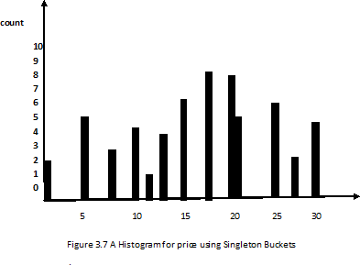

There are several partitioning rules including the following: Equal-width: The width of each bucket range is uniform

* + 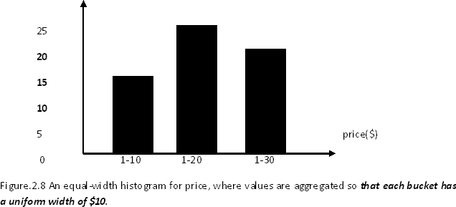(Equal-frequency (or equi-depth): the frequency of each bucket is constant

#### Clustering

Clustering technique consider data tuples as objects. They partition the objects into groups or clusters, so that objects within a cluster are similar to one another and dissimilar to objects in other clusters. Similarity is defined in terms of how close the objects are in space, based on a distance function. The quality of a cluster may be represented by its diameter, the maximum distance between any two objects in the cluster. Centroid distance is an alternative measure of cluster quality and is defined as the average distance of each cluster object from the cluster centroid.

#### Sampling:

Sampling can be used as a data reduction technique because it allows a large data set to be represented by a much smaller random sample (or subset) of the data. Suppose that a large data set D, contains N tuples, then the possible samples are Simple Random sample without Replacement (SRS WOR) of size n: This is created by drawing „n‟ of the „N‟ tuples from D (n<N), where the probability of drawing any tuple in D is 1/N, i.e., all tuples are equally likely to be sampled.

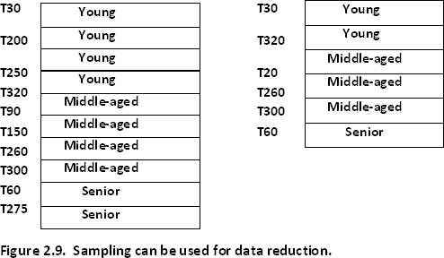

## Dimensionality Reduction:

In dimensionality reduction, data encoding or transformations are applied so as to obtained reduced or ―compressed‖ representation of the oriental data.

*Dimension Reduction Types*

* Lossless - If the original data can be *reconstructed* from the compressed data without any loss of information
* Lossy - If the original data can be reconstructed from the compressed data with loss of information, then the data reduction is called lossy.

*Effective methods in lossy dimensional reduction*

#### Wavelet transforms

1. **Principal components analysis.**

#### Wavelet transforms:

The discrete wavelet transform (DWT) is a linear signal processing technique that, when applied to a data vector, transforms it to a numerically different vector, of wavelet coefficients. The two vectors are of the same length. When applying this technique to data reduction, we consider each tuple as an n-dimensional data vector, that is, X=(x1,x2,…………,xn), depicting n measurements made on the tuple from n database attributes.

For example, all wavelet coefficients larger than some user-specified threshold can be retained. All other coefficients are set to 0. The resulting data representation is therefore very sparse, so that can take advantage of data sparsity are computationally very fast if performed in wavelet space.

The numbers next to a wave let name is the number of vanishing moment of the wavelet this is a set of mathematical relationships that the coefficient must satisfy and is related to number of coefficients.

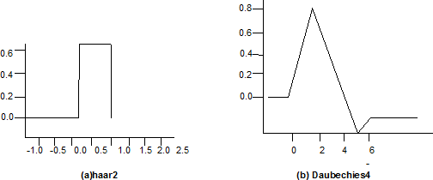

* 1. The length, L, of the input data vector must be an integer power of 2. This condition can be met by padding the data vector with zeros as necessary (L >=n).
  2. Each transform involves applying two functions
     + The first applies some data smoothing, such as a sum or weighted average.
     + The second performs a weighted difference, which acts to bring out the detailed features of data.
  3. The two functions are applied to pairs of data points in X, that is, to all pairs of measurements (X2i , X2i+1). This results in two sets of data of length *L/2*. In general,

these represent a smoothed or low-frequency version of the input data and high frequency content of it, respectively.

* 1. The two functions are recursively applied to the sets of data obtained in the previous loop, until the resulting data sets obtained are of length 2.

#### Principal components analysis

Suppose that the data to be reduced, which Karhunen-Loeve, K-L, method consists of tuples or data vectors describe by n attributes or dimensions. Principal components analysis, or PCA (also called the Karhunen-Loeve, or K-L, method), searches for k n-dimensional orthogonal vectors that can best be used to represent the data where *k*<=n. PCA combines the essence of attributes by creating an alternative, smaller set of variables. The initial data can then be projected onto this smaller set.

The basic procedure is as follows:

* The input data are normalized.
* PCA computes *k* orthonormal vectors that provide a basis for the normalized input data. These are unit vectors that each point in a direction perpendicular to the others.
* The principal components are sorted in order of decreasing significance or strength.

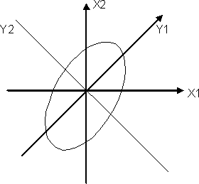

In the above figure, Y1 and Y2, for the given set of data originally mapped to the axes X1 and X2. This information helps identify groups or patterns within the data. The sorted axes are such that the first axis shows the most variance among the data, the second axis shows the next highest variance, and so on.

* The size of the data can be reduced by eliminating the weaker components.

##### Advantage of PCA

* PCA is computationally inexpensive
* Multidimensional data of more than two dimensions can be handled by reducing the problem to two dimensions.
* Principal components may be used as inputs to multiple regression and cluster analysis.

# 5. Data Transformation and Discretization

Data transformation is the process of converting data from one format or structure into another format or structure.

In *data transformation*, the data are transformed or consolidated into forms appropriatefor mining. Strategies for data transformation include the following:

1. **Smoothing**, which works to remove noise fromthe data. Techniques include binning,regression, and clustering.
2. **Attribute construction** (or *feature construction*), where new attributes are constructedand added from the given set of attributes to help the mining process.
3. **Aggregation**, where summary or aggregation operations are applied to the data. Forexample, the daily sales data may be aggregated so as to compute monthly and annualtotal amounts. This step is typically used in constructing a data cube for data analysisat multiple abstraction levels.
4. **Normalization**, where the attribute data are scaled so as to fall within a smaller range,such as 1.0 to 1.0, or 0.0 to 1.0.
5. **Discretization**, where the raw values of a numeric attribute (e.g., *age*) are replaced byinterval labels (e.g., 0–10, 11–20, etc.) or conceptual labels (e.g., *youth, adult*, *senior*).The labels, in turn, can be recursively organized into higher-level concepts, resultingin a *concept hierarchy* for the numeric attribute. Figure 3.12 shows a concept hierarchyfor the attribute *price*. More than one concept hierarchy can be defined for the sameattribute to accommodate the needs of various users.
6. 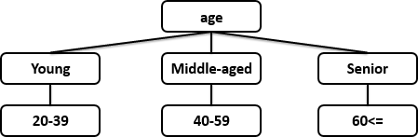**Concept hierarchy generation for nominal data**, where attributes such as *street* canbe generalized to higher-level concepts, like *city* or *country*. Many hierarchies fornominal attributes are implicit within the database schema and can be automaticallydefined at the schema definition level.

## 5.1 Data Transformation by Normalization:

The measurement unit used can affect the data analysis. For example, changing measurement units frommeters to inches for *height*, or fromkilograms to pounds for *weight*, may lead to very different results.

For distance-based methods, normalization helps prevent attributes with initially large ranges (e.g., *income*) from outweighing attributes with initially smaller ranges (e.g., binary attributes). It is also useful when given no prior knowledge of the data.

There are many methods for data normalization. We study *min-max normalization,z- score normalization,* and *normalization by decimal scaling.* For our discussion, let *A* bea numeric attribute with *n* observed values, *v*1, *v*2, …., *vn*.

1. **Min-max normalization** performs a linear transformation on the original data. Suppose that *minA*and *maxA*are the minimum and maximum values of an attribute, *A*.Min- maxnormalization maps a value, *vi*, of *A* to *vi’*in the range [*new_minA*,*new_maxA*]by computing

Min-max normalization preserves the relationships among the original data values. Itwill encounter an ―out-of-bounds‖ error if a future input case for normalization fallsoutside of the original data range for *A*.

**Example:-Min-max normalization.** Suppose that the minimum and maximum values fortheattribute *income* are $12,000 and $98,000, respectively. We would like to map *income* to the range [0.0, 1.0]. By min-max normalization, a value of $73,600 for *income* istransformed to

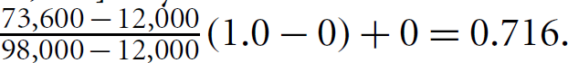

1. **Z-Score Normalization**

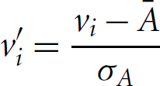The values for an attribute, *A*, are normalized based on the mean (i.e., average) and standard deviation of *A*. A value, *vi*, of *A* is normalized to *vi’* by computing

where𝐴 and A are the mean and standard deviation, respectively, of attribute A. **Example** z-score normalization. Suppose that the mean and standard deviation of the values for the attribute income are $54,000 and $16,000, respectively. With z-score normalization, a value of $73,600 for income is transformed to

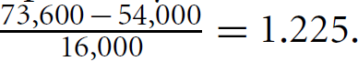

#### Normalization by Decimal Scaling:

Normalization by decimal scaling normalizes by moving the decimal point of values of attribute A. The number of decimal points moved depends on the maximum absolute value of

A. A value, vi, of A is normalized to vi’ by computing

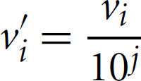

where j is the smallest integer such that max(|vi’)< 1.

**Example**Decimal scaling. Suppose that the recorded values of A range from -986 to 917. Themaximum absolute value of A is 986. To normalize by decimal scaling, we thereforedivide each value by 1000 (i.e., j = 3) so that -986 normalizes to -0.986 and 917normalizes to 0.917.

## 5.2. Data Discretization

#### Discretization by binning:

Binning is a top-down splitting technique based on a specified number of bins. Forexample, attribute values can be discretized by applying equal-width or equal-

frequencybinning, and then replacing each bin value by the bin mean or median, as in *smoothingby bin means* or *smoothing by bin medians*, respectively. These techniques can be appliedrecursively to the resulting partitions to generate concept hierarchies.

#### Discretization by Histogram Analysis:

Like binning, histogram analysis is an unsupervised discretization technique because itdoes not use class information. A histogrampartitions the values of an attribute, A, into disjoint ranges called bucketsor bins.

In anequal-width histogram, for example, the values are partitioned into equal-size partitionsor ranges (e.g., for price, where each bucket has a width of $10).With an equal- frequency histogram, the values are partitioned so that, ideally, each partitioncontains the same number of data tuples.

#### Discretization by Cluster, Decision Tree,and Correlation Analyses

Cluster analysis is a popular data discretization method. A clustering algorithm canbe applied to discretize a numeric attribute, A, by partitioning the values of A into clustersor groups.

Techniques to generate decision trees for classification can be applied todiscretization. Such techniques employ a top-down splitting approach. Unlike the othermethods mentioned so far, decision tree approaches to discretization are supervised,that is, they make use of class label information.

## Concept Hierarchy Generation for Nominal Data

Nominal attributes have a finite (but possiblylarge) number of distinct values, with no ordering among the values. Examplesinclude geographic location, job category, and item type.

Manual definition of concept hierarchies can be a tedious and time-consuming taskfor a user or a domain expert. Fortunately, many hierarchies are implicit within thedatabase schema and can be automatically defined at the schema definition level. Theconcept hierarchies can be used to transform the data into multiple levels of granularity.

* 1. **Specification of a partial ordering of attributes explicitly at the schema level byusers or experts:**A user or expert can easily define a concept hierarchy byspecifying a partial or total ordering of the attributes at the schema level.
  2. **Specification of a portion of a hierarchy by explicit data grouping:**In a large database,it is unrealistic to define an entire concept hierarchy by explicit value enumeration.For example, after specifying that province and countryform a hierarchy at the schema level, a user could define some intermediate levelsmanually.
  3. **Specification of a set of attributes, but not of their partial ordering:** A user mayspecify a set of attributes forming a concept hierarchy, but omit to explicitly

statetheir partial ordering. The systemcan then try to automatically generate the attributeordering so as to construct a meaningful concept hierarchy.

* 1. **Specification of only a partial set of attributes:** Sometimes a user can be carelesswhen defining a hierarchy, or have only a vague idea about what should be includedin a hierarchy. Consequently, the user may have included only a small subset of therelevant attributes in the hierarchy specification.



* **Data cleaning** routines attempt to fill in missing values, smooth out noise whileidentifying outliers, and correct inconsistencies in the data.
* **Data integration** combines data from multiple sources to form a coherent datastore. The resolution of semantic heterogeneity, metadata, correlation analysis,tuple duplication detection, and data conflict detection contribute to smooth dataintegration.
* **Data reduction** techniques obtain a reduced representation of the data while minimizingthe loss of information content. These include methods of *dimensionalityreduction*, *numerosity reduction*, and *data compression*.
* **Data transformation** routines convert the data into appropriate forms for mining.For example, in **normalization**, attribute data are scaled so as to fall within asmall range such as 0.0 to 1.0. Other examples are **data discretization** and **concepthierarchy generation**.
* **Data discretization** transforms numeric data by mapping values to interval or conceptlabels. Such methods can be used to automatically generate *concept hierarchies*for the data, which allows for mining at multiple levels of granularity.

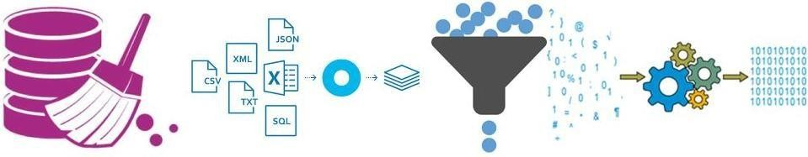

**1.7 Major issues in data mining**

Major issues in data mining are mining methodology, user interaction, performance, and diverse data types. These issues are introduced below:

*Mining methodology and user interaction issues: Mining different kinds of knowledge in databases:*

Because different users can be interested in different kinds of knowledge, data mining should cover a wide spectrum of data analysis and knowledge discovery tasks which may use same database in different ways and require the development of numerous data mining techniques.

*Interactive mining of knowledge at multiple levels of abstraction:*

Interactive mining allows users to focus the search for patterns, providing and refini8ng data mining requests based on returned results to view data and discovered patterns at multiple granularities and from different angles.

*Incorporation of background knowledge:*

Background knowledge or domain knowledge guides the discovery process in concise terms at different levels of abstraction and also speed up a data mining process, or judge the interesting of discovered patterns.

*Data mining query languages and ad hoc data mining :*

High-level data mining query languages need to be developed to allow users to describe ad hoc data mining tasks by facilitating the specification of the relevant sets of data for analysis, the domain knowledge, the kinds of knowledge to be mined, and the conditions and constraints to be enforced on the discovered patterns.

*Presentation and visualization of data mining results:*

Using visual representations, or other expressive forms, the knowledge can be easily understood and directly usable by humans. This requires the system to adopt expressive knowledge representation techniques, such as tree, tables, rules, graphs, charts, crosstabs, matrices, or curves.

*Handling noisy or incomplete data:*

Background knowledge or domain knowledge guides the discovery process in concise terms at different levels of abstraction and also speed up a data mining process, or judge the interesting of discovered patterns.

*Data mining query languages and ad hoc data mining :*

High-level data mining query languages need to be developed to allow users to describe ad hoc data mining tasks by facilitating the specification of the relevant sets of data for analysis, the domain knowledge, the kinds of knowledge to be mined, and the conditions and constraints to be enforced on the discovered patterns.

*Presentation and visualization of data mining results:*

Using visual representations, or other expressive forms, the knowledge can be easily understood and directly usable by humans. This requires the system to adopt expressive knowledge representation techniques, such as tree, tables, rules, graphs, charts, crosstabs, matrices, or curves.

*Handling noisy or incomplete data:*

Noise or incomplete data may be confuse the process, causing the knowledge model constructed to over fit the data which intern result the accuracy of the discovered patterns to be poor data clearing methods and data analysis methods that can handle noise are required, as well as outlier mining methods for the discovery and analysis of exceptional cases.

*Pattern evolution – the interestingness problem:*

A data mining system can uncover thousands of patterns. Many of the patterns discovered may be uninteresting to the given user, either because they represent common knowledge or lack novelty. Several challenges 0remain regarding the development of techniques to asses the interestingness of discovered patterns, particularly with regard to subjective measures that estimate the value of patterns with respect to a given user class, based on user beliefs or expectations. The use of interestingness measure or user specified constraints to guide the discovery process and reduce the screech space in another active area of research

*Performance issues*: This include efficiency scalability, and parallelization of data mining algorithm

*Efficiency and scalability of data mining algorithms*:

In order to effectively extract for information from huge amount data in databases, data mining algorithms must be efficient and scalable as well as running time of a data mining algorithms must predictable and acceptable.

*Parallel, distributed, and incremental mining algorithms*:

The huge size of databases, wide distribution of data, high cost and computational complexity of data mining methods leads to the developments of parallel and distributed data mining algorithms moreover, the incremental data mining algorithms updates database without having to mine this entire data again “from scratch”

**Issues relating to the diversity of database types**

Handling of relational and complex types of data:

It is unrealistic to expect one system to mine all kinds of data, given the diversity of data types and different goals of data mining specific data mining systems should be constructed for mining specific kinds of data. Therefore, one may expect to have different data mining systems for different kinds of data.

Mining information from heterogeneous databases and global information systems:

Data mining may help disclose high level data regularities in multiples heterogeneous databases that are unlikely to be discovered by simple query systems and may improve information exchange and interoperability in heterogeneous databases. Web mining, with uncovers interesting knowledge about web contents, web structures, web usage, and web dynamics, becomes a very challenging and fast evolving field in data mining.

Data mining systems relay on databases to supply raw data for input and this raises problems in that databases tend be dynamic, incomplete, noisy, and data large. Other problems arise as a result of the adequacy relevance of the information stored. The above issues are considered major requirements and challenges for the further evolution of data mining technology.